**Community Classroom**

Lec1 :

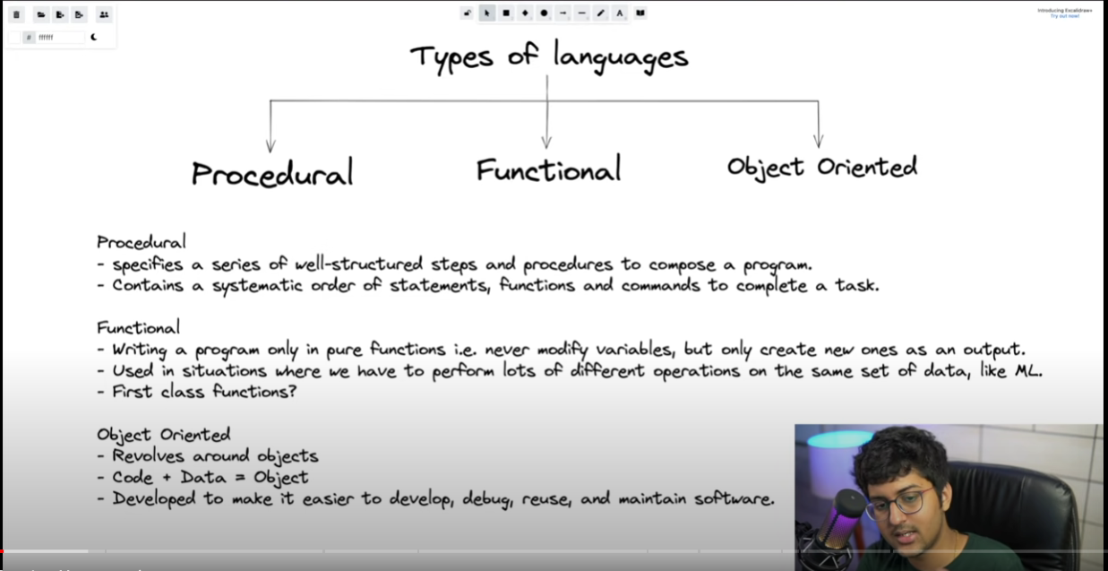

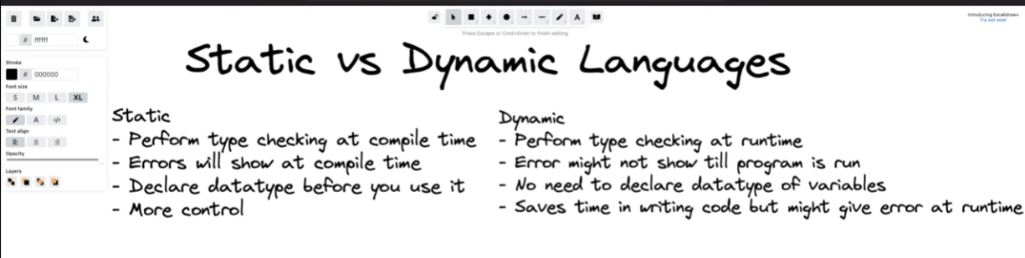

Let say

A = 10

A= “soumya”

It will not create an error for dynamic language

Object reference variable:

There are two types of memory

1. Stack memory
2. Heap Memory

A=10

A = reference varstored in stack memory and 10 object stored in Heap

Garbage collection : Memory space which is not pointed by any other variable

**LEC2 : GITHUB and Use :**

|  |  |
| --- | --- |
| **1** | To check Git is installed or not :  Command : git  o/p : |
| **2.** | Unix commad :  ls ,  ls –a (for hidden files /folders) |
| **3** | Git init : to start git repo using initialisation  git config --global user.email [soumyadeepsen97@gmail.com](mailto:soumyadeepsen97@gmail.com) : to initialize gmail and account setup  Git status : to see all the newly added commands  Git add . : to add all the files in current directory  Git add abc.txt : to add abc.txt files into github  Git commit –m “the comment” - > to commit the changes  Git log : for all the changes  Git reset <logid > : torestore the files till exact logid  Git stash : to store all the previously deleted files in uncommitted to stored file  Git stash pop : all the previously commited things are again configured  Git stash clean : clean  Now connect with git repo :  git remote add origin https://github.com/soumyadeep28/DSA-HUB.git  : this command will connect the repository (origin is the name of url in short)  git push -u origin main : to push the files to git  git remote –v means : what all the links are connected |
| **4** | Git branch <newbranch_name> : this is to create new branch    Git checkout <newbranch_name> :it will switch to new branch from master  HEAD points to the new branch |